Retiree Volunteerism

Interaction Mechanism Design

Jeff Black, Ishitha Michael, Dan Roberts,  
 Brodrick Stigall

November 9, 2022

## Introduction

Our research team conducted Grounded Theory interviews with retirees representing four different lifestyles to understand the decisions they make in finding and assimilating into volunteer roles. The two most significant findings in analyzing those interviews are that retirees do not use automated tools to find research opportunities, relying instead on “word of mouth” from acquaintances, internal email newsletters, and their knowledge of their community’s need and secondly, once they engage in a volunteer role, they prefer to personalize their experience in a way that provides them self-actualization on their own terms. In some instances, they personalize that role to reflect their careers prior to retirement but in many instances personalize it to do something completely different. Once in their role, they are enthusiastic about sharing their experience with their acquaintances and encouraging them to join them in a volunteer-centered social network. Our design goal then is to devise an interaction mechanism that facilitates this outreach approach by building on existing volunteer opportunity email newsletters with addition of automated recommender and elicitation capabilities.

The main practices that our interaction mechanism design will support reflect the interviewees’ feedback that volunteers find opportunities rather organically and that the preferred tool for communicating within their social circle is email. Our interaction mechanism is an email-based newsletter which displays lists of volunteer opportunities based on user-defined preference based communities (i.e., peer groups). A full system would allow users to view and add new peers and events to each peer group, as well as create and join new peer groups, with the search/viewing process being aided by recommender systems. Such a system capitalizes on the fact that retirees often use email services, and also aids users in the organic snowballing process by allowing them to form communities and share opportunities within those communities.

## Design

This section presents our design (See **Figure 1** below**)** for an interaction mechanism that addresses the primary needs identified in our interviewee research and grounded theory analysis - that retirees learn of volunteer activities through word or mouth, they prefer email for communication within their peer groups, and they want to personalize their volunteer role to fit their specific self-actualization needs. In addition, the design has variants that can balance the user’s desire for privacy with their interest in sharing or responding to volunteer recommendations within their peer-group community.

**Figure 1 - Interaction Mechanism Design**

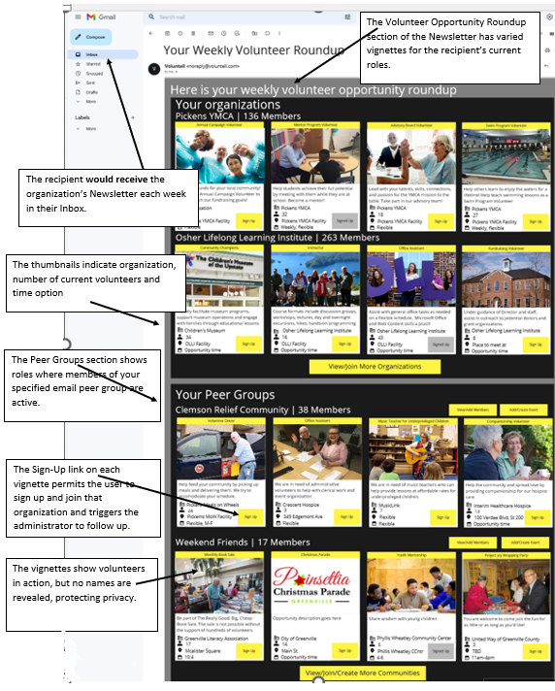

## Motivation for the interaction mechanism

The motivation in designing our interaction mechanism was to find a way to automate “word of mouth” by retirees in promoting volunteer participation while protecting user privacy with a tool that would be familiar and easy to use. We decided to take this email-embedded, user-defined preference based communities approach for numerous reasons. We used a grounded theory analysis of interviews with retiree (and near retiree) volunteers, and came to three main things about the process of finding volunteer opportunities. First, the degree to which an opportunity fits their needs and desires for volunteering (e.g., related to interests/motivations, availability) determines whether they will pursue a volunteer opportunity in the first place. Second, once volunteers have joined a volunteer opportunity, they end up finding their niche–that is, they’ll personalize their experience or learn about new opportunities through word-of-mouth and interpersonal relationships. Lastly, retiree volunteers often use email to keep up with peers and volunteer opportunities.

Given that retiree volunteers use email newsletters, we knew we wanted to build on top of the traditional email newsletter based approach for distributing information about opportunities. So, we started with a newsletter of newsletters, per se (See **Figure 2)**. That is, we started with an email newsletter that allows users to add multiple volunteer organizations to their newsletter and receive a weekly update about opportunities from the different organizations they added. This approach of extending the functionality of already-used technology may help in the adoption of technologies for retirees or specific users in general.

**Figure 2: Email-based newsletter design**

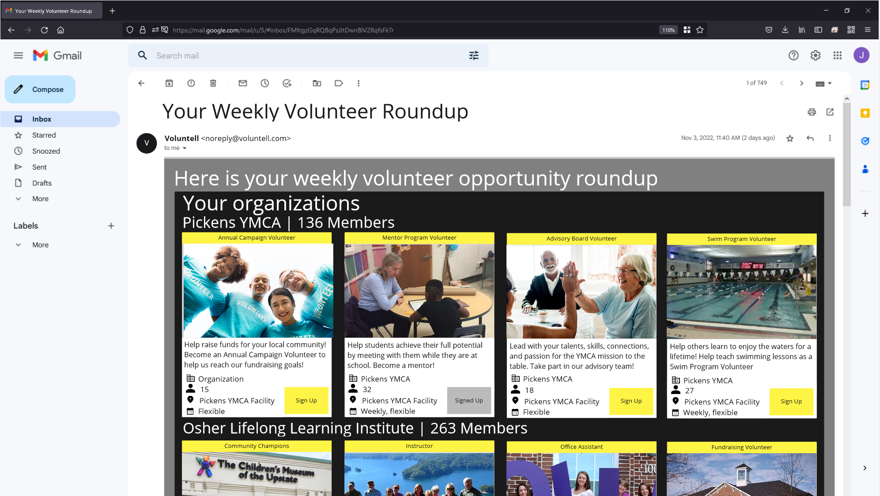

Additionally, to allow users to organically learn about new opportunities through social networks of volunteers, we built in a peer group system (see **Figure 3**). That is, a second grouping of volunteer opportunities that is based not on specific organizations a user has added to their newsletter, but groups of volunteers that they have added to their newsletter. Specifically, a peer group is a user-defined preference-based community. That is, users create, join, and add events to peer groups. The events that have been added to a peer group are included on the newsletter of each person in the peer group. This peer group system enables users to create small networks of volunteers that share opportunities with each other, just like how our interviewees told us they find opportunities. Furthermore, the process of finding peer groups, adding users to peer groups, and adding events to them are supported by a recommender system, that way users can explore new potential opportunities and communities. If the user wishes to introduce a new event to the system entirely, they can. Though, the specific process of finding new peer groups, organizations, and events are not the specific focus of our design variants (as discussed later). Allowing users to craft their own preference-based communities, but supporting the communities with recommender systems may be a broadly-applicable approach to building preference-based communities in decision contexts which are heavily guided by close, interpersonal relationships.

**Figure 3: Peer group system**

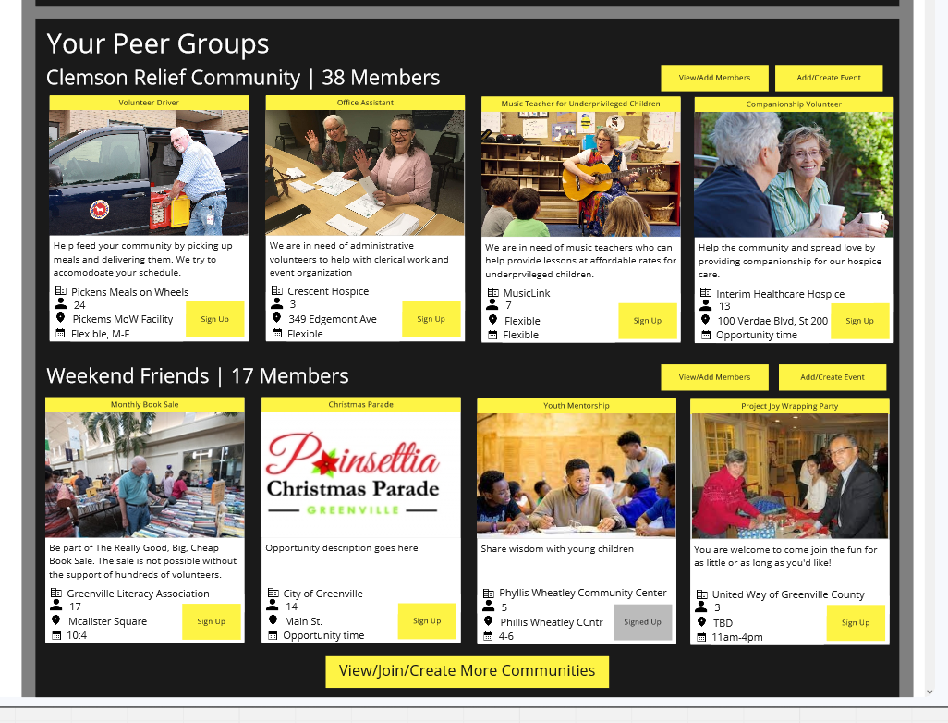

Lastly, in order to support the ability for users to see how well an opportunity fits, we knew it would be important to allow them to see relevant information regarding the opportunities we show them. So, we decided to display such information like location (e.g., specific location, remote), the amount of people signed up, the date/time/frequency, a description of the opportunity, and an image representing the type of volunteer work that might be done (see **Figure 4**). Beyond our decision context, understanding what information users need and tailoring displays to those needs is a way to improve the likelihood that the information helps the user.

**Figure 4: Information about fit**

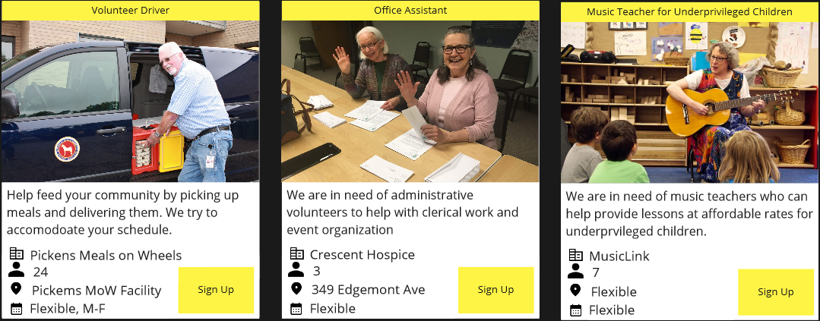

Lastly, if a user decides that they wish to join an opportunity, they can join the opportunity by pressing the “sign up” button, which takes them to a page where they can complete any formal registration required for the event.

## Explanation of variants

We decided to have two additional variants of our design, each differing on the level of privacy and community it affords the user. Generally speaking, as the level of community increases, the level of privacy the users have decreases. That is because of the information required to generate preference-based communities or allow users to create their own preference-based communities.

Our first variant scores low on community, but high on privacy. That is because it is simply an email newsletter where the user subscribes to organizations, then receives emails with lists of opportunities from each organization. Very little information about the user is needed–the only information needed is the organizations they subscribe to, and the opportunities they have signed up for. In the case that the user wishes to add more organizations to their newsletter, they can press a button labeled “View/Join More Organizations” and be taken to a page where they can view and search volunteer organizations within the system that they can join (see **Figure 5**).

**Figure 5: View/Join More Organization in low community variant**

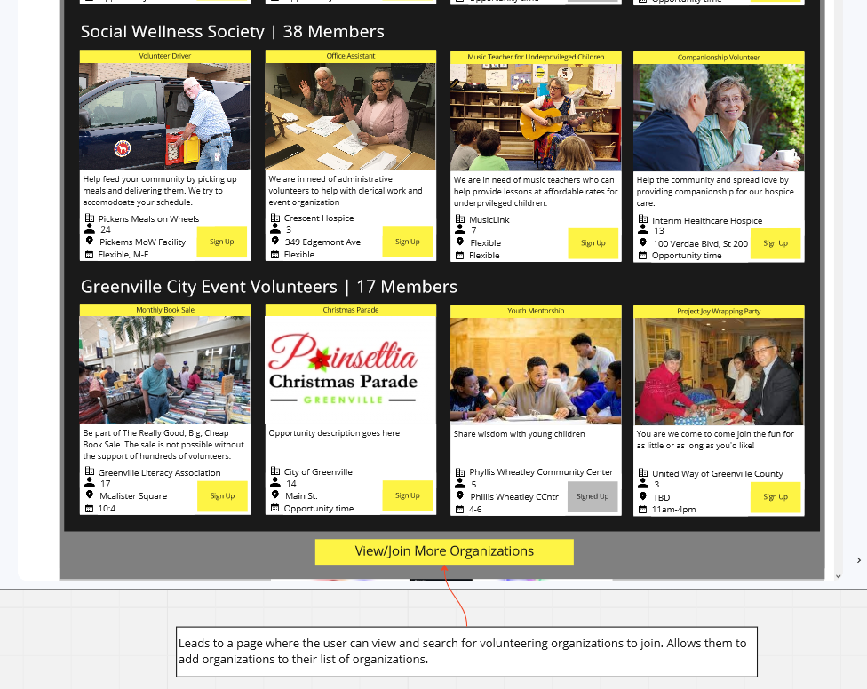

Our second variant is a medium privacy, medium community version of our design. Where, alongside the list of subscribed organizations, an additional list of opportunities based on auto-recommended preference-based communities is displayed (see **Figure 6)**. While the user can not edit the preference-based communities they are a part of, they can add different organizations to their organization subscriptions. This variant is medium community because it introduces recommendations based on preference-based communities, meaning that users with similar interests are more likely to meet and start an organic interpersonal relationship. This variant is medium privacy because of the information required to generate the recommendations.

**Figure 6: Preference-based communities in the medium community variant**

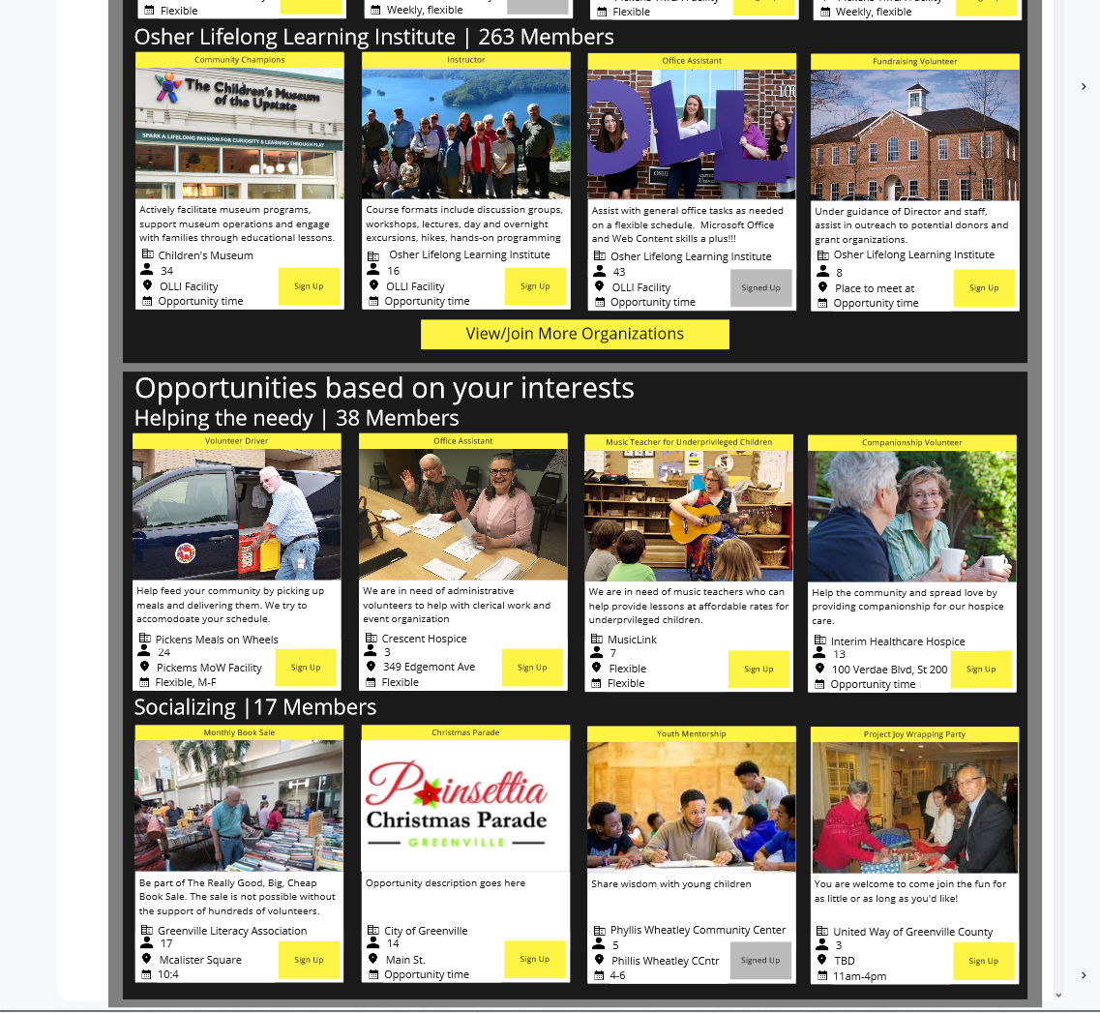

## 

## Appendix

**Main mechanism: Low privacy, high community**

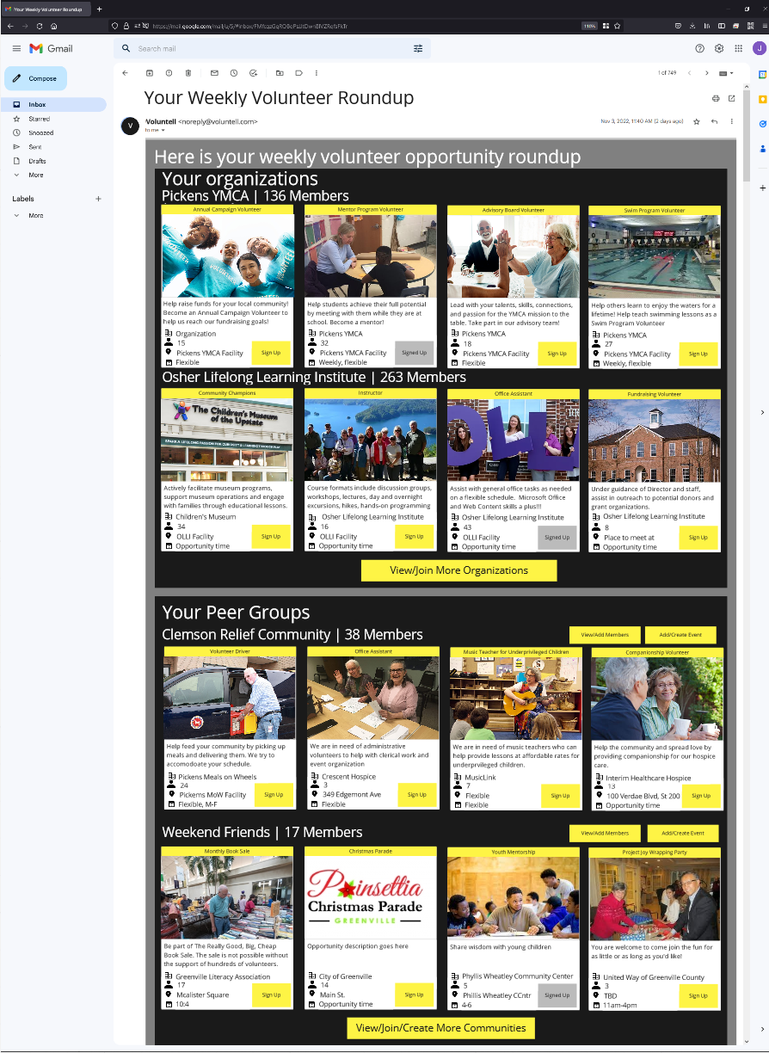

**Variant 1: High privacy, low community**

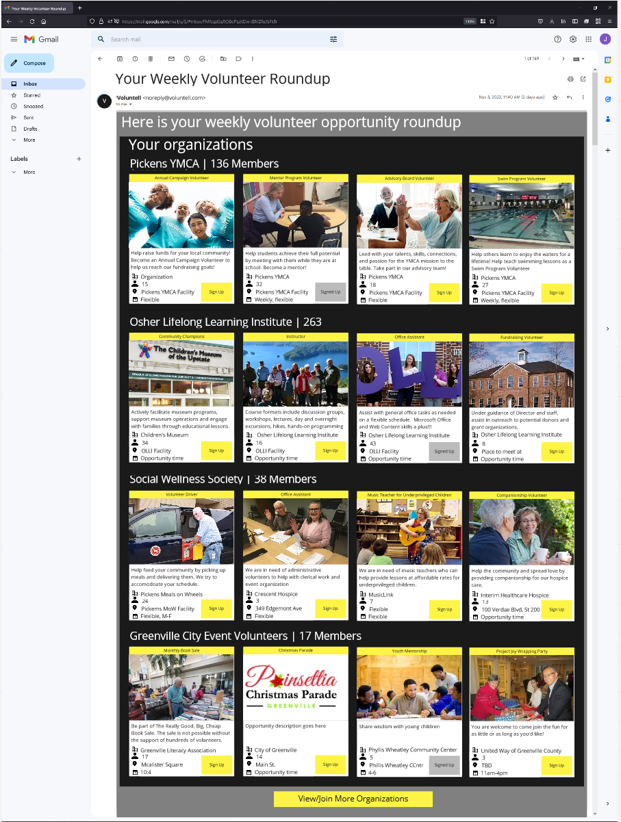

**Variant 2: Medium privacy, medium community**

